Willie X.

STAT 390 - Group 2

Time Series Prediction Project Final Report

**I. Abstract**

This data science project aims to accurately predict the number of new cases of COVID-19 for some of the G20 and G24 countries using regression with linear, tree-based, and neural network models. First, our group preprocessed the data focusing on issues like missingness and multicollinearity using solutions like clustering and correlation matrix as well as dealing with missingness differently for different types of machine learning models: ARIMA, AutoARIMA, Prophet (Univariate), Prophet (Multivariate), XGBoost, and LSTM. Next, each group member focused on a specific type of model to examine and create and preprocess training, testing, and validation sets for model tuning along with feature engineering and variable and/or model transformations. Overall, the best-performing model based on my results is the XGBoost model with a log transformation on the new cases of COVID-19.

**II. Project and Data Overview**

**A. Project Overview**

The goal of this time series projection is to predict new cases of COVID-19 for G20 and G24 countries on a country level using 6 regression models: ARIMA, AutoARIMA, Prophet (Univariate), Prophet (Multivariate), XGBoost, and LSTM. By determining the best model(s) in predicting new cases of COVID-19, health organizations will be able to determine where and when to combat emerging large cases of COVID-19.

The dataset used is originally from Kaggle titled *Our World in Data - COVID-19*[1], which originally contains 341,000 observations and 67 variables. The variable of interest as a response variable for the models will be **new_cases.** Some notable predictors other than **date** include:

COVID data:

**total_deaths** / **new_deaths** = The amount of deaths due to COVID occurring

**reproduction_date** = Real-time estimate of reproduction rate of COVID

**positive_rate** = The share of COVID tests that are positive

Geographic data:

**continent** = The continent where the new cases of COVID are occurring

**location** = The country where the new cases of COVID are occurring

Country data

**population_density** = Population of country divided by its land area

**gdp_per_capita** = Gross domestic product of a country

**extreme_poverty** = Share of population living in extreme poverty

Hospital data

**icu_patients** / **hosp_patients** = Number of COVID patients in the icu / hospital

**total_tests** / **total_vaccinations** = Total tests and vaccinations for COVID taken

The models use information due to geography, countries, hospitals, and COVID in order to better accurately predict the trend of new cases of COVID as indicated by **new_cases.**

**B. Data Overview and Preprocessing**

From the initial 67 predictors, 2 hold no significant value:

**iso_code** = country code **tests_units** = units COVID is measured in.

Next, variable missingness is addressed. As shown in Table 1 in the Appendices, there are 34 predictors that have large missingess as indicated by the low completion rate. However, 4 predictors may be significant in predicting new_cases as indicated in Table 2 in the Appendices:

**new_tests** **total_vaccinations** **total_tests** **positive_rate**

Note there are other predictors in Table 2 with higher correlation not mentioned above since these variables have large missingness due to country related reasons and thus, are not usable such as **hosp_patients**. Next, the last data cleaning step is to remove predictors with multicollinearity issues. As shown in Table 3 in the Appendices, there are 8 predictors that have multicollinearity issues:

**new_cases_smoothed new_deaths_smoothed median_age**

**aged_65_older aged_70_older**

Finally, after removing some scaled predictors such as **_smooted** or **_per_million** predictors, there are a total of 38 predictors remaining along with 1 response = **new_cases** with 32,000 observations. There was only one main challenge in preprocessing which was that some predictors have large missingness due to country related issues as mentioned above so each large missingness was analyzed individually to determine if the missingness was random.

At this point for feature engineering, 4 new predictors are created: an indicator variable, **G20**, to determine if a country is in the G20 (1) or not (0) and another indicator variable for **G24**, **month** to indicate an observation’s current month (1-12), and **day_of_week** to indicate an observation’s current day in the week (Monday-Sunday). Then, the dataset is split into its training and testing set with training having observations before January 2023 and testing having observations starting January 2023. At this point, the data is also then differentiated into 3 datasets each for a different type of model: linear, tree-based, and neural nets.

Finally, to fix any remaining random missingness, a k-means clustering model was implemented using all the time-independent predictors, **life_expectancy, female_smokers,** and **male_smokers**, which were normalized in order to compare distances, to find the optimal number of clusters to group the data using the metric average silhouette[2]. Since most of the random missingness is between February 1, 2021 and March 1, 2022, then any missingness from a predictor is imputed with the median value of that predictor’s cluster. Missingness outside the aforementioned date range will be handled differently by different models.

For linear models, any predictors still with missingness are removed from the linear model dataset. Additionally, outliers are checked by using the Cook’s distance method with a critical value of 0.5, which provides results that suggest there aren't any substantial outliers. For tree-based models, any predictors still with missingness are imputed with a very large value, 1015, in the tree-based dataset. Finally, for neural network models, any predictors still with missingness will have an indicator predictor generated which indicates if value is present (TRUE) or missing (FALSE). Specifically, the only predictors with such indicators are **total_tests_b, new_tests_b, positive_rate_b, total_vaccinations_b,** and **people_vaccinated_b**.

Additionally, one main issue with the response, **new_cases**, is that some countries reported their new_cases differently or changed their reporting method. In the dataset, India, Italy, Japan, Pakistan, Saudi Arabia, Sri Lanka, and the United Kingdom always reported their new cases daily. France and Germany reported their new cases weekly while Argentina, Mexico, Australia, Canada, Colombia, Ecuador, Ethiopia, Morocco, Philippines, Russia, South Africa, South Korea, Turkey, and the United States all changed their daily new cases reporting to weekly reporting after some point in time. In order to be able to model each data comparably, **new_cases** is turned into daily data if it wasn’t already. The solution implemented is to average the **new_cases** if weekly into daily **new_cases**. To check the preprocessing, refer to the preprocessing files located in **Preprocessing Code/Final Preprocessing** in the Github repository[3] in the Appendices. After all the preprocessing is done, each of the linear, tree-based, and neural network datasets have a training set with 25,000 observations and a testing set with 6,000 observations.

**III: Methodology**

**A. ARIMA Model**

**1. Data Preparation**

Using the linear dataset, first the data is filtered to only have observations after the first instance of COVID-19 for any country in the dataset which is January 4, 2020. Next, each country’s daily data is transformed into weekly data using a weekly rolling average.

Next, check if a country has stationary or non-stationary data using the Augmented Dickey-Fuller Test with an alpha level of 0.05. As indicated in Table 4 of the Appendices, the only **non-stationary** countries are:

**Australia Canada France Germany Italy**

**Russia Sri Lanka United-Kingdom**

For model parameter tuning, the training set of the linear data is used to create validations sets using a rolling origin backtesting method. For each validation set, the training part is a year worth of observations by country = 53 observations, the testing set is 2 months worth of observations by country = 8 observations, and the validation sets are incremented by 4 months by country = 16 observations for a total of 6 validation sets. For the ARIMA model, 1 parameter is fixed and 6 parameters to be tuned with possible values:

|  |  |
| --- | --- |
| Fixed | Tune |
| * seasonal_period = “auto” | * non_seasonal_ar = {0, 2, 4} * non_seasonal_differences = {0, 1, 2} * non_seasonal_ma = {0, 2, 4} * seasonal_ar = {0, 2, 4} * seasonal_differences = {0, 1, 2} * seasonal_ma = {0, 2, 4} |

**2. Model Building**

Using R’s *arima* package directly resulted in issues where the model was consistently a line regardless if the data was stationary or non-stationary. Thus, the solution was to implement the ARIMA process manually. First, to model any data in general is Response = Trend + Error. For ARIMA, specifically, is Response = **Linear Trend + Seasonality + Error**. The **linear trend** can be modeled using a simple linear regression from R’s built-in lm() function. The **seasonality** can be modeled alongside lm() by treating seasonality as a categorical regressor. Finally, the **error** can be modeled using an ARIMA model where the parameters mentioned above will be tuned by minimizing the metric root mean squared error, RMSE. Finally, the predicted linear trend added with the predicted seasonality and predicted error from ARIMA will be the final prediction to the response variable, new_cases. The predictor used to predict the response **new_cases** is only **date**.

Another issue is that the first few weeks of any country generally has very low or 0 cases of COVID which skews the linear trend so a solution was that the linear trend will only be modeled using observations after the first 3 months of the training data. Finally, to check if the each country is stationary through this new process after removing linear trend and seasonality, refer to the results in Table 5 of the Appendices where the only **stationary** countries are:

**Ecuador Japan Mexico Morocco Pakistan**

**Russia South Korea Turkey United States**

Additionally, another major issue with the ARIMA model in R is that **seasonal_period** = “auto” else the model takes a much longer time to tune parameters. After applying a regular grid of 3 levels for each of the 6 parameters to be tuned resulting in 36 = 729 parameter combinations on the 6 validation sets, the results of the best parameters for each country are (p,d,q,P,D,Q):

|  |  |  |  |  |  |  |
| --- | --- | --- | --- | --- | --- | --- |
| Country | Argentina | Australia | Canada | Colombia | Ecuador | Ethiopia |
| Parameters | 4,1,2,2,0,0 | 2,0,4,2,0,2 | 2,0,2,1,0,2 | 4,2,0,2,2,2 | 4,2,4,1,0,1 | 4,0,2,2,0,1 |
| Country | France | Germany | India | Italy | Japan | Mexico |
| Parameters | 4,0,0,1,0,1 | 4,0,2,1,0,1 | 2,0,2,2,0,0 | 4,2,4,2,0,1 | 4,0,0,2,1,0 | 2,2,4,2,0,2 |
| Country | Morocco | Pakistan | Philippines | Russia | Saudi Arabia | South Africa |
| Parameters | 0,0,2,2,0,2 | 4,0,2,2,0,0 | 0,0,2,1,1,0 | 4,2,2,2,0,0 | 4,2,2,2,0,1 | 2,0,0,0,0,0 |
| Country | South Korea | Sri Lanka | Turkey | United Kingdom | United States |  |
| Parameters | 2,2,4,2,0,2 | 4,2,2,2,0,0 | 2,1,0,2,2,1 | 0,1,0,1,0,0 | 2,0,2,2,0,0 |  |

Additionally, in order to improve performance by lowering the metric RMSE, I applied a log transformation to **new_cases** and then applied the ARIMA process. An issue with log transformation is that log cannot be applied to **new_cases** = 0 so a solution is to convert all log(0) into 0. As indicated in Table 6 in the Appendices, the only non-stationary countries:

**Australia Ethiopia France Sri Lanka Turkey**

The results for the best parameters for log ARIMA:

|  |  |  |  |  |  |  |
| --- | --- | --- | --- | --- | --- | --- |
| Country | Argentina | Australia | Canada | Colombia | Ecuador | Ethiopia |
| Parameters | 4,1,4,2,0,2 | 0,1,2,2,0,1 | 2,2,4,2,0,1 | 2,2,0,2,0,1 | 2,1,4,2,1,0 | 4,0,2,2,1,2 |
| Country | France | Germany | India | Italy | Japan | Mexico |
| Parameters | 4,2,4,2,0,0 | 2,0,0,2,1,0 | 0,1,0,2,0,2 | 2,1,0,2,1,1 | 2,0,4,2,0,2 | 4,0,4,2,1,1 |
| Country | Morocco | Pakistan | Philippines | Russia | Saudi Arabia | South Africa |
| Parameters | 4,2,2,2,1,0 | 4,1,0,2,1,1 | 2,2,4,2,0,2 | 2,0,4,2,0,1 | 4,0,2,1,1,2 | 4,0,2,2,0,0 |
| Country | South Korea | Sri Lanka | Turkey | United Kingdom | United States |  |
| Parameters | 0,0,4,0,0,1 | 4,2,0,2,1,1 | 2,1,0,2,0,1 | 4,0,4,1,0,2 | 4,2,2,2,1,1 |  |

**3. Model Performance**

The RMSE for the ARIMA and log ARIMA models on the training and testing sets:

|  |  |  |  |  |  |  |
| --- | --- | --- | --- | --- | --- | --- |
| Country | Argentina | Australia | Canada | Colombia | Ecuador | Ethiopia |
| Train RMSE | 2751 | 2769 | 1247 | 1458 | 424 | 200 |
| Test RMSE | 16177 | 37152 | 7372 | 6219 | 1772 | 332 |
| log Train RMSE | 3880 | 13186 | 1553 | 3540 | 1168 | 708 |
| log Test RMSE | 43006 | 52424 | 546 | 4967 | 4967 | 113 |
| Country | France | Germany | India | Italy | Japan | Mexico |
| Train RMSE | 7313 | 4521 | 11142 | 5033 | 9687 | 1774 |
| Test RMSE | 96537 | 95225 | 53727 | 32833 | 123645 | 8437 |
| log Train RMSE | 21455 | 10187 | 19202 | 9263 | 32591 | 3414 |
| log Test RMSE | 11917 | 52656 | 2736 | 2823 | 134905 | 4694 |
| Country | Morocco | Pakistan | Philippines | Russia | Saudi Arabia | South Africa |
| Train RMSE | 470 | 384 | 2249 | 3255 | 236 | 1307 |
| Test RMSE | 1442 | 1012 | 4436 | 22070 | 1478 | 3380 |
| log Train RMSE | 668 | 2236 | 2807 | 3693 | 330 | 2075 |
| log Test RMSE | 23 | 33 | 341 | 3160 | 99 | 132 |
| Country | South Korea | Sri Lanka | Turkey | United Kingdom | United States |  |
| Train RMSE | 11581 | 162 | 5101 | 8679 | 20925 |  |
| Test RMSE | 101029 | 487 | 34135 | 47814 | 126535 |  |
| log Train RMSE | 20944 | 520 | 5809 | 6992 | 43808 |  |
| log Test RMSE | 1022714 | 4 | 1 | 1629 | 16005 |  |

Generally, the log transformed ARIMA model isn’t as accurate on the training set, but improves the testing set’s accuracy. The R code for the ARIMA model is in Github Repository in **Models/regular/wx_arima.R** and **Models/log/wx_arima_log.R**.

Plots of a Stationary Country - United States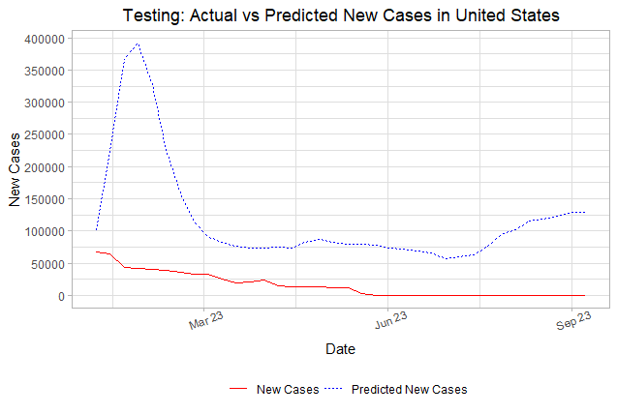

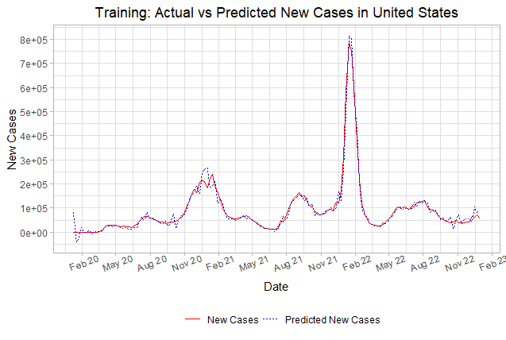

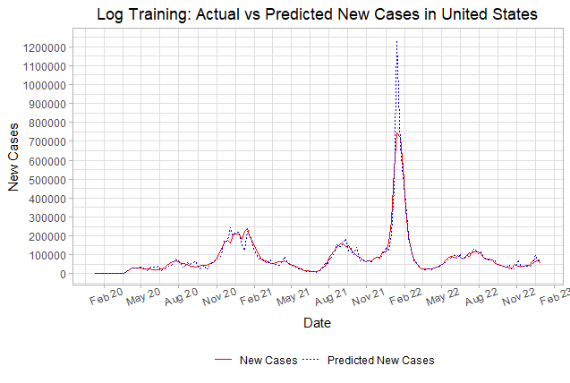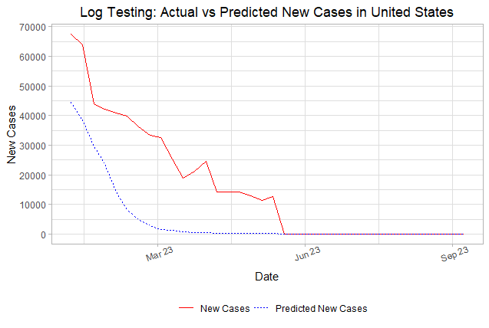

Plots of a Non-Stationary Country - Germany

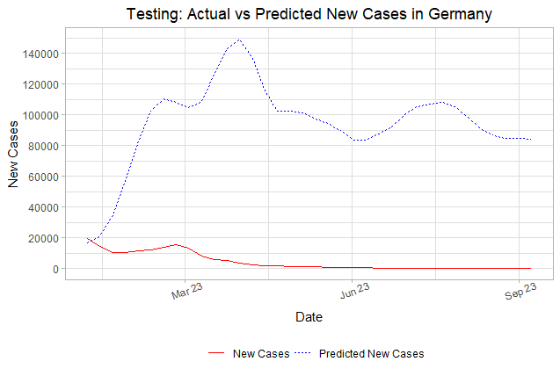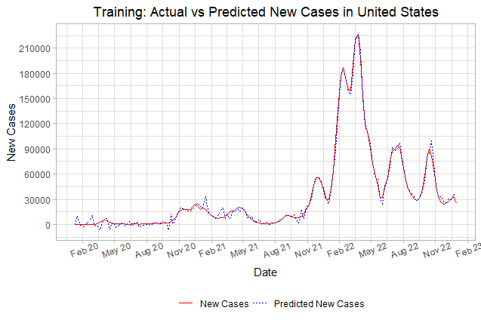

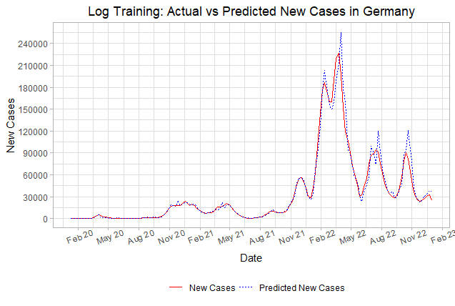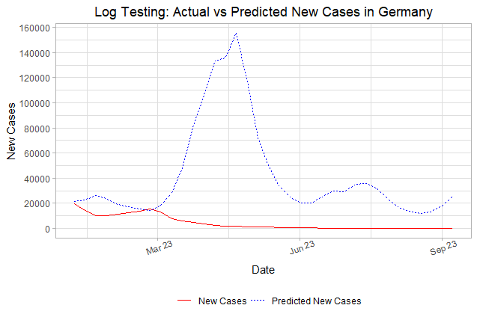

**B. AutoARIMA Model**

**1. Data Preparation**

The process applied to the ARIMA model is applied to the AutoARIMA model. First, the linear dataset is filtered to only have observations after the first instance of COVID-19. Next, each country’s daily data is transformed into weekly data using a weekly rolling average.

Similarly to ARIMA, check if a country has stationary or non-stationary data using the Augmented Dickey-Fuller Test with an alpha level of 0.05 as indicated in Table 4 of the Appendices.Similarly to ARIMA, the validations sets are constructed from the linear training set using a rolling origin backtesting method for a total of 6 validation sets. For the AutoARIMA model, 1 parameter is fixed and 6 parameters to be tuned with possible values:

|  |  |
| --- | --- |
| Fixed | Tune |
| * seasonal_period = 53 | * non_seasonal_ar = {0, 2, 4} * non_seasonal_differences = {0, 1, 2} * non_seasonal_ma = {0, 2, 4} * seasonal_ar = {0, 2, 4} * seasonal_differences = {0, 1, 2} * seasonal_ma = {0, 2, 4} |

**2. Model Building**

Similarly to ARIMA, using R’s *auto_arima* package directly resulted in issues where the model was consistently a line regardless if the data was stationary or non-stationary. Thus, the solution was to implement the ARIMA process manually as described in ARIMA. Also, all the issues mentioned in ARIMA are also issues for AutoARIMA which are addressed similarly. Thus, the stationary check remains the same as the results in ARIMA as presented in Table 5 of the Appendix. Thus, the only difference between the ARIMA and AutoARIMA models is the R packages used to implement each model. The predictor used to predict the **new_cases** is **date**.

Additionally, seasonal_period = 53 for the 53 weeks in a year accounting for leap years since R’s auto_arima package is able to deal with seasonal_period ≠ “auto” without the time setbacks. Finally, applying a regular grid of 3 levels for each of the 6 parameters to be tuned resulting in 36 = 729 parameter combinations on the 6 validation sets, the results of the best parameters for each country are (p,d,q,P,D,Q):

|  |  |  |  |  |  |  |
| --- | --- | --- | --- | --- | --- | --- |
| Country | Argentina | Australia | Canada | Colombia | Ecuador | Ethiopia |
| Parameters | 2,0,2,0,0,0 | 0,1,4,0,0,0 | 0,0,4,0,0,0 | 0,1,0,0,0,0 | 4,0,2,0,0,0 | 0,0,2,0,0,0 |
| Country | France | Germany | India | Italy | Japan | Mexico |
| Parameters | 2,0,2,0,0,0 | 0,1,4,0,0,0 | 2,0,4,0,0,0 | 2,1,0,0,0,0 | 0,0,4,0,0,0 | 0,0,4,0,0,0 |
| Country | Morocco | Pakistan | Philippines | Russia | Saudi Arabia | South Africa |
| Parameters | 0,0,4,0,0,0 | 4,0,0,0,0,0 | 0,1,2,0,0,0 | 4,0,2,0,0,0 | 0,0,4,0,0,0 | 4,0,0,0,0,0 |
| Country | South Korea | Sri Lanka | Turkey | United Kingdom | United States |  |
| Parameters | 2,1,0,0,0,0 | 4,1,0,0,0,0 | 2,1,0,0,0,0 | 0,0,4,0,0,0 | 0,1,2,0,0,0 |  |

Additionally, in order to improve performance by lowering the metric RMSE, I applied a log transformation to **new_cases** and then applied the AutoARIMA process. Since the AutoARIMA process is the same as ARIMA process, it has the same issues as ARIMA with the same solutions implemented. The stationary check is the same with Table 6 in the Appendices.

The results for the best parameters for log AutoARIMA:

|  |  |  |  |  |  |  |
| --- | --- | --- | --- | --- | --- | --- |
| Country | Argentina | Australia | Canada | Colombia | Ecuador | Ethiopia |
| Parameters | 2,0,0,0,0,0 | 0,1,0,0,0,0 | 2,0,2,0,0,0 | 2,0,0,0,0,0 | 4,0,2,0,0,0 | 0,0,4,0,0,0 |
| Country | France | Germany | India | Italy | Japan | Mexico |
| Parameters | 4,0,2,0,0,0 | 2,0,0,0,0,0 | 4,0,0,0,0,0 | 0,1,4,0,0,0 | 0,0,2,0,0,0 | 0,1,2,0,0,0 |
| Country | Morocco | Pakistan | Philippines | Russia | Saudi Arabia | South Africa |
| Parameters | 0,0,4,0,0,0 | 2,0,2,0,0,0 | 0,1,0,0,0,0 | 4,0,0,0,0,0 | 0,0,4,0,0,0 | 2,0,2,0,0,0 |
| Country | South Korea | Sri Lanka | Turkey | United Kingdom | United States |  |
| Parameters | 0,0,4,0,0,0 | 2,2,0,0,0,0 | 2,0,2,0,0,0 | 4,1,2,0,0,0 | 4,0,2,0,0,0 |  |

**3. Model Performance**

The RMSE for the AutoARIMA and log AutoARIMA models on the training and testing sets:

|  |  |  |  |  |  |  |
| --- | --- | --- | --- | --- | --- | --- |
| Country | Argentina | Australia | Canada | Colombia | Ecuador | Ethiopia |
| Train RMSE | 2789 | 2872 | 1297 | 1713 | 423 | 246 |
| Test RMSE | 19440 | **17139** | 8648 | 5958 | 1880 | 402 |
| log Train RMSE | 3916 | 13965 | 1674 | 8256 | 405 | 315 |
| log Test RMSE | **8579** | 140080 | 643 | **1174** | 1495 | **37** |
| best ARIMA RMSE | 16177 | 37152 | **546** | 4967 | **1772** | 113 |
| Country | France | Germany | India | Italy | Japan | Mexico |
| Train RMSE | 7436 | 5883 | 10933 | 5237 | 10524 | 1981 |
| Test RMSE | 105095 | 112814 | 57545 | 72417 | **96071** | 12385 |
| log Train RMSE | 20123 | 7264 | 27470 | 7259 | 31111 | 2650 |
| log Test RMSE | 68979 | 646442 | 2838 | 8369 | 257184 | 22386 |
| best ARIMA RMSE | **11917** | **52656** | **2736** | **2823** | 123645 | **4694** |
| Country | Morocco | Pakistan | Philippines | Russia | Saudi Arabia | South Africa |
| Train RMSE | 361 | 392 | 1557 | 3163 | 269 | 1259 |
| Test RMSE | 1340 | 1155 | 5195 | 44662 | 793 | 3629 |
| log Train RMSE | 841 | 1237 | 2315 | 4658 | 381 | 2400 |
| log Test RMSE | 145 | 36 | 421 | 21085 | 139 | 145 |
| best ARIMA RMSE | **23** | **33** | **341** | **3160** | **99** | **132** |
| Country | South Korea | Sri Lanka | Turkey | United Kingdom | United States |  |
| Train RMSE | 11692 | 182 | 4354 | 9296 | 33525 |  |
| Test RMSE | **101376** | 536 | 35506 | 43918 | 174562 |  |
| log Train RMSE | 21274 | 490 | 5937 | 7933 | 27484 |  |
| log Test RMSE | 987080 | **4** | 397 | 1929 | 16713 |  |
| best ARIMA RMSE | 1022714 | **4** | **1** | **1629** | **16005** |  |

Similar to the ARIMA model, generally, the log transformed AutoARIMA model isn’t as accurate on the training set, but improves the testing set’s accuracy. Compared to the best test RMSE from the ARIMA model, generally AutoARIMA performs worse than the ARIMA model. A possible explanation for this result is that the seasonality for AutoARIMA is manually set which is not the most optimal seasonality as determined in the ARIMA model so the difference in performance in the model is solely due to the implementation of each model in each of their R packages. The R code for the AutoARIMA model is in Github Repository in **Models/regular/wx_autoarima.R** and **Models/log/wx_autoarima_log.R**.

Plots of a Stationary Country - United States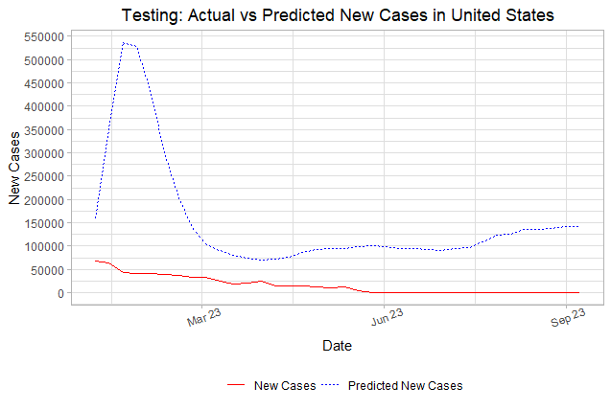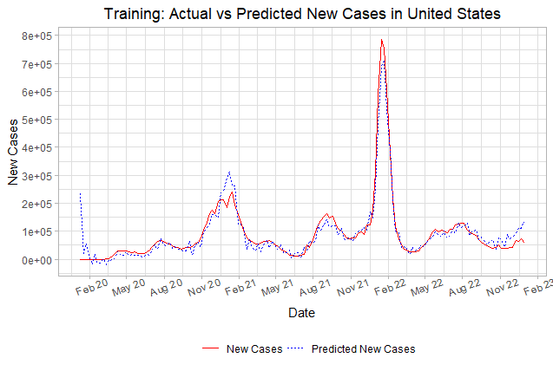

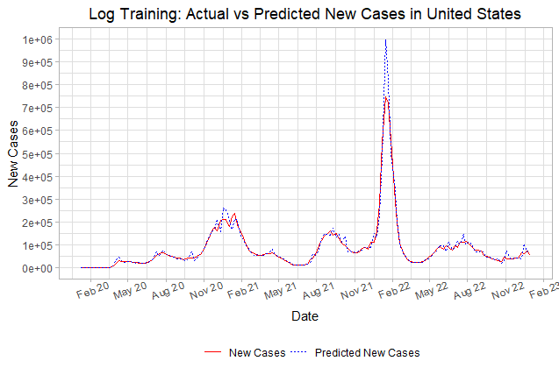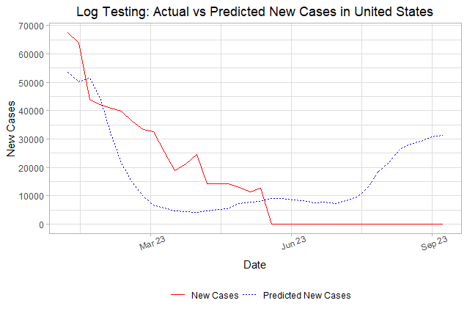

Plots of a Non-Stationary Country - Germany

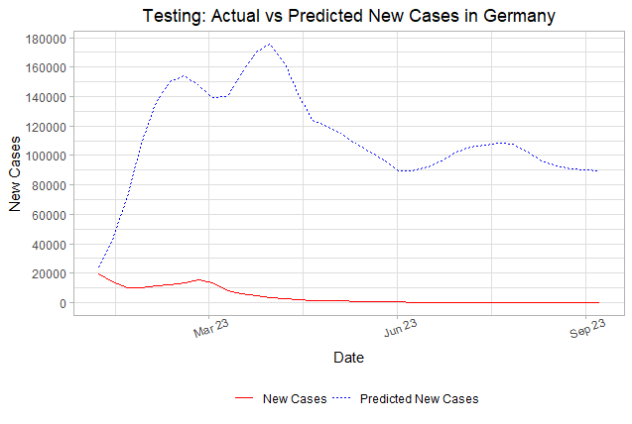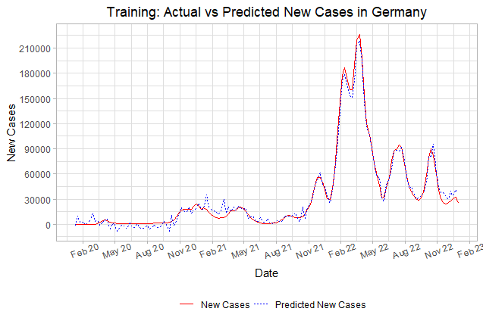

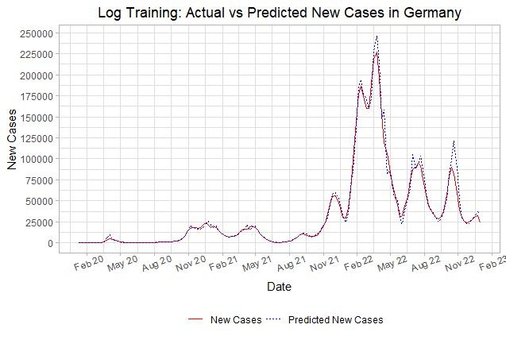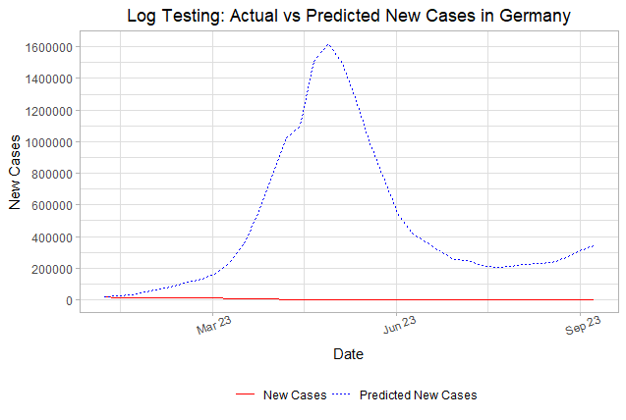

**C. Prophet (Univariate) Model**

**1. Data Preparation**

Since the ARIMA model only uses one predictor, **date**, ARIMA is generally not as accurate in predicting the response as compared to Prophet which can use more than one predictor. For the Prophet (Univariate) model, the linear data is used since the Prophet model is a linear model in which there is only one predictor, **date**, for univariate. First, the data is filtered to only have observations after the first instance of COVID-19 for any country in the dataset which is January 4, 2020. Next, each country’s daily data is transformed into weekly data using a weekly rolling average.

For model parameter tuning, the training set of the linear data is used to create validations sets using a rolling origin backtesting method. For each validation set, the training part is a year worth of observations per country = 23*53 observations, the testing set is 2 months worth of observations per country = 23*8 observations, and the validation sets are incremented by 4 months per country = 23*16 observations for a total of 6 validation sets. Also, Prophet (Univariate) has 3 fixed parameter and 5 parameters to be tuned with possible values:

|  |  |
| --- | --- |
| Fixed | Tune |
| * growth = “linear” * season = “additive” * seasonality_weekly = TRUE | * changepoint_num = {0, 25, 50} * changepoint_range = {0.6, 0.75, 0.9} * prior_scale_changepoints = {0.001, 0.316, 100} * prior_scale_seasonality = {0.001, 0.316, 100} * prior_scale_holidays = {0.001, 0.316, 100} |

**2. Model Building**

The Prophet (Univariate) model was implemented using R’s *prophet* package directly following an example at R-bloggers[4]. A small issue with the prophet models at the beginning is that the model constantly returns saw-like graphs. However, this problem was due to the rolling origin backtesting validation sets were not implemented correctly for this model at the beginning since our group forgot to account for the repeated dates due to the dataset having daily observations from several countries. This issue was resolved by multiplying the lengths of each part of the validation sets by 23, the number of countries in the dataset, as noted above in Data Preparation. After applying model tuning for Prophet using a regular grid of 3 levels for each of the 5 parameters to be tuned resulting in 35 = 243 parameter combinations on the 6 validation sets, the results of the best parameters that minimizes the metric RMSE are:

**changepoint_num** = 25 **changepoint_range** = 0.75

**prior_scale_changepoints** = 100 **prior_scale_seasonality** = 100

**prior_scale_holidays** = 0.001

Additionally, in order to improve performance by lowering the metric RMSE, I applied a log transformation to **new_cases** and then, applied the Prophet model tuning with the best parameters that minimizes the metric RMSE are:

**changepoint_num** = 25 **changepoint_range** = 0.6

**prior_scale_changepoints** = 0.316 **prior_scale_seasonality** = 0.001

**prior_scale_holidays** = 0.316

**3. Model Performance**

The RMSE for the Prophet (Univariate) and log Prophet (Univariate) models on the training and testing sets:

|  |  |  |  |  |  |  |
| --- | --- | --- | --- | --- | --- | --- |
| Country | Argentina | Australia | Canada | Colombia | Ecuador | Ethiopia |
| Train RMSE | 12162 | 12796 | 11518 | 14746 | 14536 | 15308 |
| Test RMSE | 4274 | 5091 | 8190 | 6422 | 10649 | 11066 |
| log Train RMSE | 14813 | 18875 | 5176 | 7621 | 1085 | 616 |
| log Test RMSE | 1408 | 3178 | 446 | 658 | 111 | 51 |
| Country | France | Germany | India | Italy | Japan | Mexico |
| Train RMSE | 42687 | 39923 | 67365 | 20353 | 45607 | 11890 |
| Test RMSE | 20680 | 19346 | 29049 | 9394 | 36683 | 6405 |
| log Train RMSE | 59568 | 51398 | 75490 | 31564 | 47183 | 7833 |
| log Test RMSE | 2753 | 4712 | 3839 | 2618 | 40091 | 841 |
| Country | Morocco | Pakistan | Philippines | Russia | Saudi Arabia | South Africa |
| Train RMSE | 14922 | 14996 | 13735 | 21997 | 15037 | 15756 |
| Test RMSE | 10416 | 10155 | 8510 | 5311 | 10821 | 8136 |
| log Train RMSE | 1801 | 1700 | 5342 | 26569 | 1137 | 4878 |
| log Test RMSE | 124 | 192 | 400 | 3890 | 114 | 371 |
| Country | South Korea | Sri Lanka | Turkey | United Kingdom | United States |  |
| Train RMSE | 60603 | 15343 | 13284 | 23031 | 103184 |  |
| Test RMSE | 17097 | 10913 | 6178 | 9756 | 66128 |  |
| log Train RMSE | 65245 | 1002 | 20433 | 28293 | 101471 |  |
| log Test RMSE | 21974 | 49 | 1861 | 1645 | 14828 |  |

While the prophet model performs somewhat well on the untransformed **new_cases** as indicated by the somewhat low test RMSE for each country, the prophet model performs well on the log transformed **new_cases** as indicated by the low test RMSE for each country. The R code for Prophet (Univariate) is in Github Repository in **Models/regular/wx_prophet_single.R** and **Models/log/wx_prophet_single_log.R**.

Plots of a Stationary Country - United States

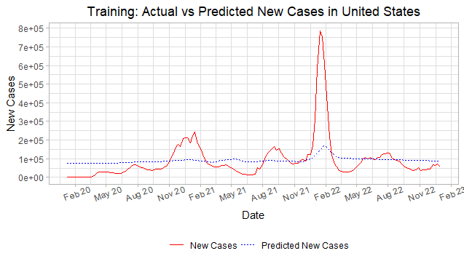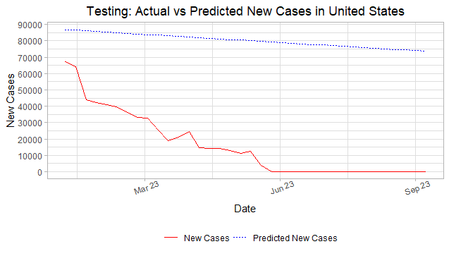

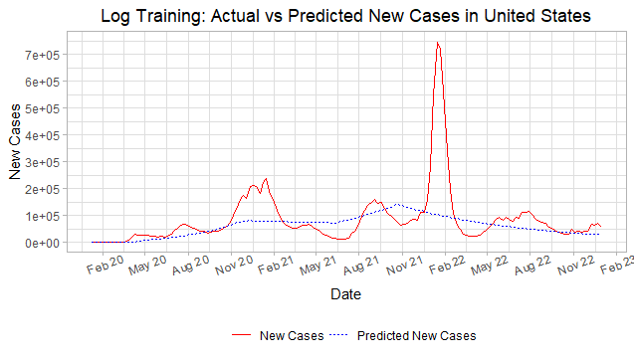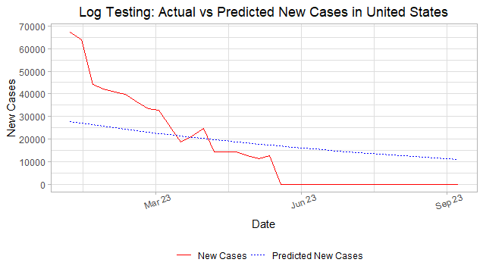

Plots of a Non-Stationary Country - Germany

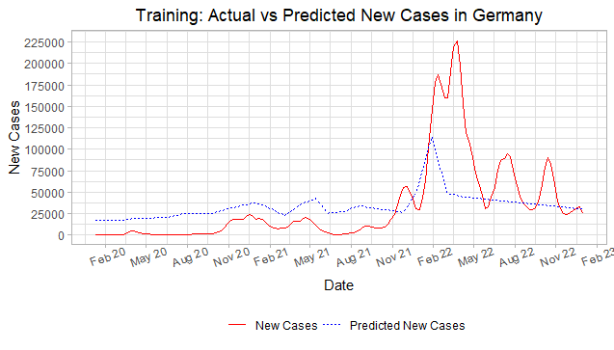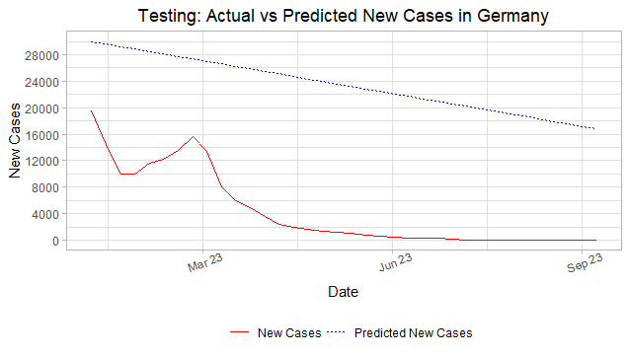

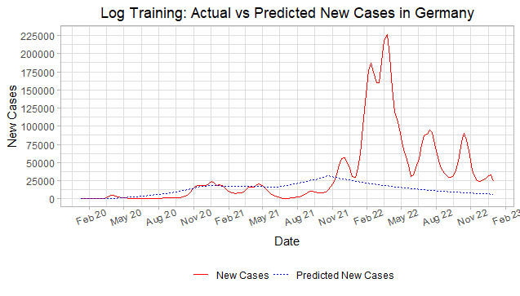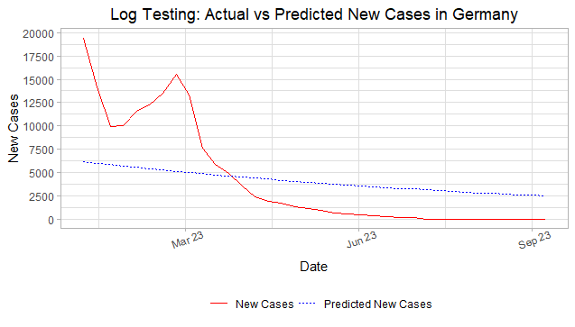

D. Prophet (Multivariate) Model

**1. Data Preparation**

For the Prophet (Multivariate) model, the linear data is used since the Prophet model is a linear model in which all the predictors are used. First, the data is filtered to only have observations after the first instance of COVID-19 for any country in the dataset which is January 4, 2020. Next, each country’s daily data is transformed into weekly data using a weekly rolling average. Additionally, any variables with high correlation are removed using R’s **step_corr()** function with a critical value of 0.7. Finally, all categorical predictors are converted into dummy variables.

Similarly to Prophet (Univariate), the validations sets are constructed from the linear training set using a rolling origin backtesting method per country for a total of 6 validation sets. The Prophet (Multivariate) model has 3 fixed parameter and 5 parameters to be tuned with possible values:

|  |  |
| --- | --- |
| Fixed | Tune |
| * growth = “linear” * season = “additive” * seasonality_weekly = TRUE | * changepoint_num = {0, 25, 50} * changepoint_range = {0.6, 0.75, 0.9} * prior_scale_changepoints = {0.001, 0.316, 100} * prior_scale_seasonality = {0.001, 0.316, 100} * prior_scale_holidays = {0.001, 0.316, 100} |

**2. Model Building**

Similar to the Prophet (Univariate), the Prophet (Multivariate) model will be implemented using R’s *prophet* package directly. There is still the constant issue with the prophet models constantly returning saw-like graphs in which I applied possible solutions as mentioned in Prophet (Univariate). With still this issue present, after applying model tuning for Prophet using a regular grid of 3 levels for each of the 5 parameters to be tuned resulting in 35 = 243 parameter combinations on the 6 validation sets, the results of the best parameters that minimizes the metric RMSE are:

**changepoint_num** = 50 **changepoint_range** = 0.9

**prior_scale_changepoints** = 0.001 **prior_scale_seasonality** = 100

**prior_scale_holidays** = 0.001

Additionally, in order to improve performance by lowering the metric RMSE, I applied a log transformation to new_cases and then, applied the Prophet model tuning with the best parameters that minimizes the metric RMSE are:

**changepoint_num** = 50 **changepoint_range** = 0.75

**prior_scale_changepoints** = 0.001 **prior_scale_seasonality** = 0.316

**prior_scale_holidays** = 0.001

**3. Model Performance**

The RMSE for the Prophet (Multivariate) and log Prophet (Multivariate) models on the training and testing sets as well as the best Test RMSE for Prophet (Univariate) which is the Test RMSE for the log transformed Prophet (Univariate):

|  |  |  |  |  |  |  |
| --- | --- | --- | --- | --- | --- | --- |
| Country | Argentina | Australia | Canada | Colombia | Ecuador | Ethiopia |
| Train RMSE | 2927 | 2231 | 1898 | 1841 | 1528 | 1836 |
| Test RMSE | 3250 | 7145 | 3535 | 2813 | 3023 | 2381 |
| log Train RMSE | 2536 | 7344 | 1446 | 1241 | 511 | 244 |
| log Test RMSE | **722** | **2220** | **373** | **84** | **48** | **12** |
| best Uni RMSE | 5502 | 6351 | 4840 | 6237 | 4670 | 5957 |
| Country | France | Germany | India | Italy | Japan | Mexico |
| Train RMSE | 6080 | 4784 | 10264 | 5860 | 12494 | 3161 |
| Test RMSE | 9746 | 8326 | 3127 | 4364 | 15119 | 2719 |
| log Train RMSE | 11370 | 9741 | 9205 | 4719 | 18593 | 2208 |
| log Test RMSE | 6136 | 7455 | **683** | **2900** | **4719** | **465** |
| best Uni RMSE | **5808** | **7147** | 5385 | 4836 | 40213 | 3181 |
| Country | Morocco | Pakistan | Philippines | Russia | Saudi Arabia | South Africa |
| Train RMSE | 1887 | 1685 | 1969 | 4999 | 1706 | 1751 |
| Test RMSE | 2959 | 3163 | 3106 | 2535 | 2992 | 2283 |
| log Train RMSE | 408 | 437 | 1276 | 5786 | 288 | 1176 |
| log Test RMSE | **8** | **22** | **361** | **1391** | **32** | **97** |
| best Uni RMSE | 4481 | 4162 | 2912 | 6077 | 2910 | 3508 |
| Country | South Korea | Sri Lanka | Turkey | United Kingdom | United States |  |
| Train RMSE | 11574 | 1652 | 3011 | 7249 | 18287 |  |
| Test RMSE | 13515 | 2906 | 5533 | 3490 | 14778 |  |
| log Train RMSE | 9071 | 312 | 3216 | 7092 | 62245 |  |
| log Test RMSE | 21803 | **5** | **4** | **1676** | **10949** |  |
| best Uni RMSE | **21411** | 3358 | 2434 | 2790 | 24392 |  |

For the Prophet (Multivariate), it appears that the non transformed performs somewhat well as indicated by the somewhat low test RMSE, but the log transformed Prophet (Multivariate) is one of the best performing models as indicated by the extremely low test RMSE even for countries like the United States and Japan. In fact, the log transformed Prophet (Multivariate) basically outperforms the log transformed Prophet (Univariate) as indicated by the lower test RMSE in the log test RMSE compared to the Prophet (Univariate)’s lowest test RMSE. This is most likely due to the Prophet (Multivariate) having additional information such as country data like **gdp_per_capita** and **population_density** and hospital data like **icu_patients** and **total_tests** which helped it make better predictions compared to Prophet (Univariate) which only had information based on just **date**. The R code for the Prophet (Multivariate) model is in Github Repository in **Models/regular/wx_prophet_multiple.R** and **Models/log/wx_prophet_multiple_log.R**.

Plots of a Stationary Country - United States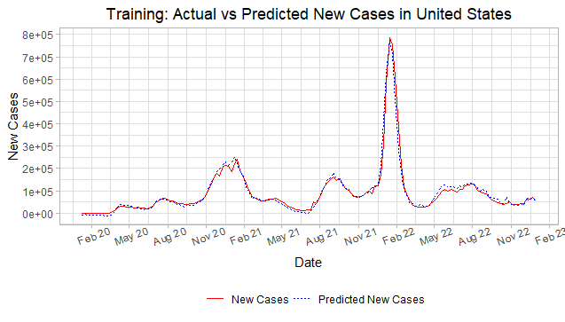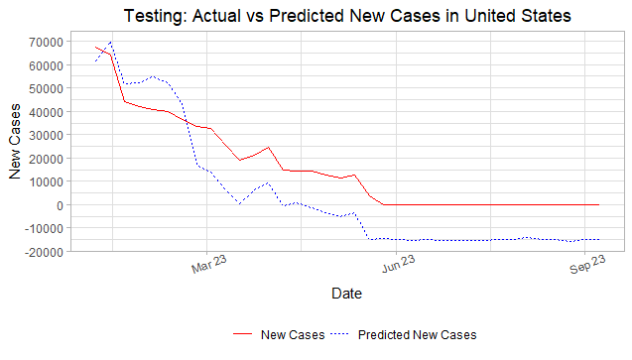

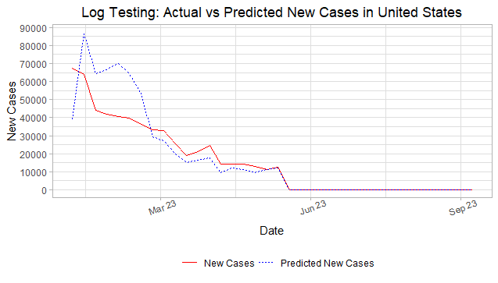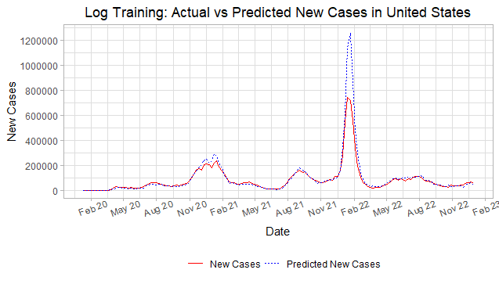

Plots of a Non-Stationary Country - Germany

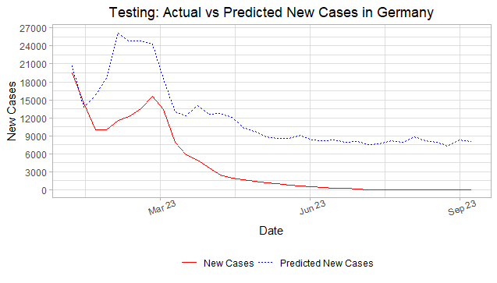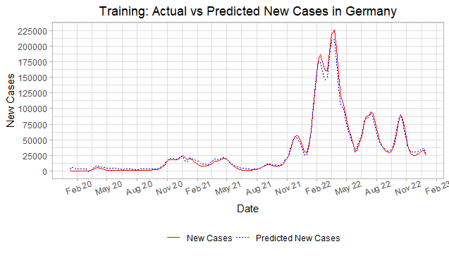

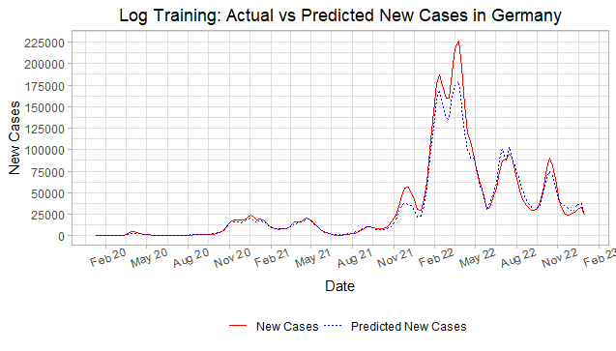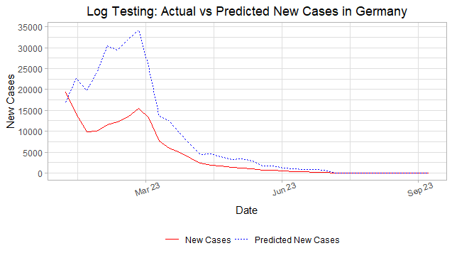

E. XGBoost Model

**1. Data Preparation**

Using the tree-based dataset, first the data is filtered to only have observations after the first instance of COVID-19 for any country in the dataset which is January 4, 2020. Next, 3 new predictors are created: 1 week lagged variable for **new_cases**, 2 week lagged variable for **new_cases**, and 1 month lagged variable for **new_cases**. Finally, all categorical predictors are converted into dummy variables.

For model parameter tuning, the training set of the linear data is used to create validations sets using a rolling origin backtesting method. For each validation set, the training part is a year worth of observations per country = 23*366 observations, the testing set is 2 months worth of observations per country = 23*60 observations, and the validation sets are incremented by 4 months per country = 23*120 observations for a total of 6 validation sets. For the XGBoost model, no parameters are fixed and 5 parameters are to be tuned with possible values:

|  |  |
| --- | --- |
| Fixed | Tune |
|  | * trees = {500, 1000, 1500} * tree_depth = {2, 11, 20} * learn_rate= {0.001, 0.0178, 0.316} * min_n = {5, 10, 15} * mtry = {5, 15, 25} |

**2. Model Building**

The XGBoost model was implemented using R’s *xgboost* package directly using an example[5] by a Data Scientist for Posit, Julia Silge. An issue with the XGBoost model was that it was performing very poorly without information based on time. Thus, a solution implemented was to create several lagged variables of the response **new_cases** which vastly improved the performance of the XGBoost model. Applying model tuning for XGBoost using a regular grid of 3 levels for each of the 5 parameters to be tuned resulting in 35 = 243 parameter combinations on the 6 validation sets, the results of the best parameters that minimizes the metric RMSE are:

**trees** = 1000 **tree_depth** = 2 **learn_rate** = 0.316

**min_n** = 10 **mtry** = 25

Additionally, in order to improve performance by lowering the metric RMSE, I applied a log transformation to **new_cases** and then, applied the XGBoost model tuning with the best parameters that minimizes the metric RMSE are:

**trees** = 1000 **tree_depth** = 20 **learn_rate** = 0.0178

**min_n** = 10 **mtry** = 25

**3. Model Performance**

The RMSE for the XGBoost and log XGBoost models on the training and testing sets:

|  |  |  |  |  |  |  |
| --- | --- | --- | --- | --- | --- | --- |
| Country | Argentina | Australia | Canada | Colombia | Ecuador | Ethiopia |
| Train RMSE | 2564 | 2223 | 1549 | 1773 | 964 | 629 |
| Test RMSE | 5354 | 12856 | 6389 | 4100 | 2416 | 2056 |
| log Train RMSE | 91 | 59 | 30 | 35 | 17 | 4 |
| log Test RMSE | 292 | 1611 | 279 | 44 | 47 | 2 |
| Country | France | Germany | India | Italy | Japan | Mexico |
| Train RMSE | 4745 | 3744 | 4691 | 4898 | 6234 | 2190 |
| Test RMSE | 18441 | 22620 | 10799 | 14501 | 64125 | 9010 |
| log Train RMSE | 174 | 164 | 416 | 129 | 469 | 56 |
| log Test RMSE | 1358 | 2486 | 834 | 1407 | 20480 | 518 |
| Country | Morocco | Pakistan | Philippines | Russia | Saudi Arabia | South Africa |
| Train RMSE | 849 | 882 | 1358 | 2426 | 580 | 1786 |
| Test RMSE | 2319 | 2098 | 4579 | 13588 | 2039 | 2131 |
| log Train RMSE | 9 | 10 | 40 | 118 | 6 | 66 |
| log Test RMSE | 7 | 3 | 198 | 1970 | 17 | 52 |
| Country | South Korea | Sri Lanka | Turkey | United Kingdom | United States |  |
| Train RMSE | 4410 | 732 | 3011 | 4207 | 9378 |  |
| Test RMSE | 56720 | 1555 | 1243 | 6367 | 58104 |  |
| log Train RMSE | 795 | 5 | 99 | 124 | 6059 |  |
| log Test RMSE | 18173 | 1 | 1 | 612 | 10273 |  |

The XGBoost model without log transformation is one of the better performing models in predicting new cases of COVID as indicated by the low test RMSE relative to the other models mentioned above thus far. In fact, XGBoost with a log transformation is the best performing model compared to every other model thus far except for some of the Prophet models for a few countries. The R code for XGBoost model is in Github Repository in **Models/regular/wx_xgboost.R** and **Models/log/wx_xgboost_log.R**.

Plots of a Stationary Country - United States

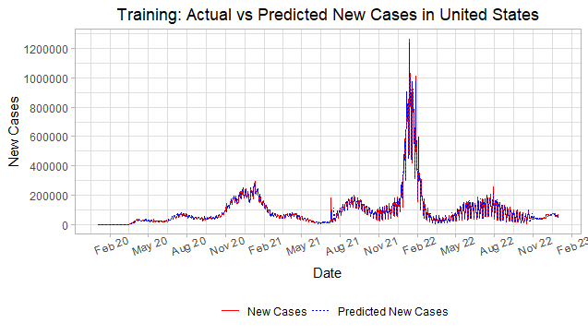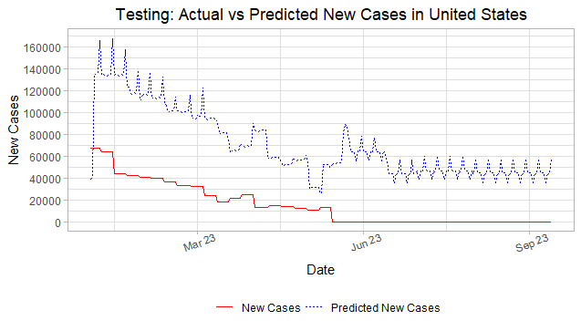

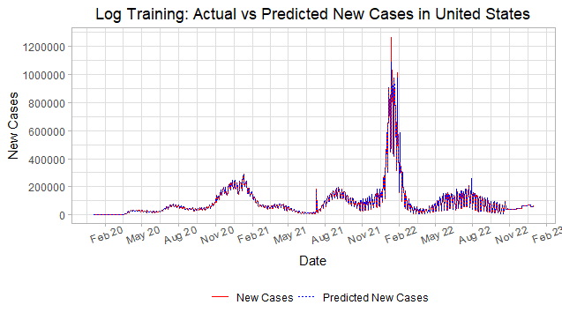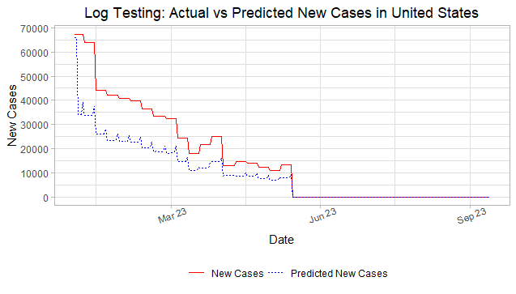

Plots of a Non-Stationary Country - Germany

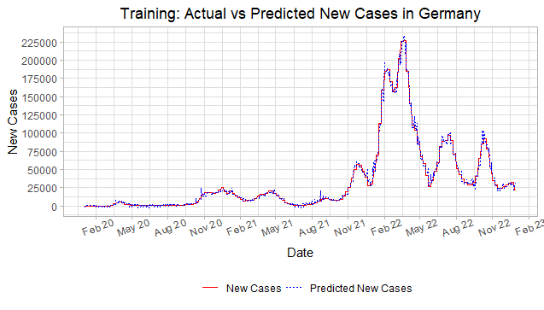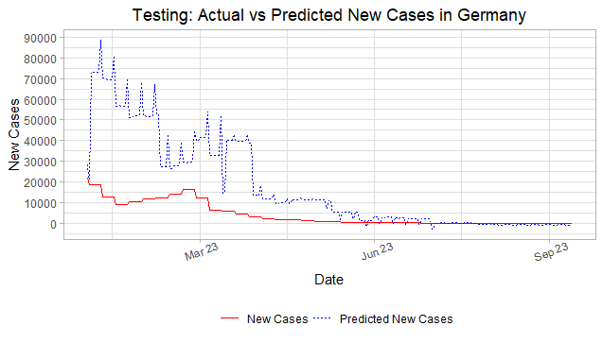

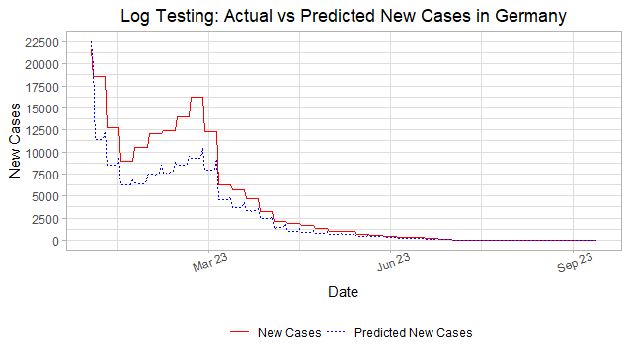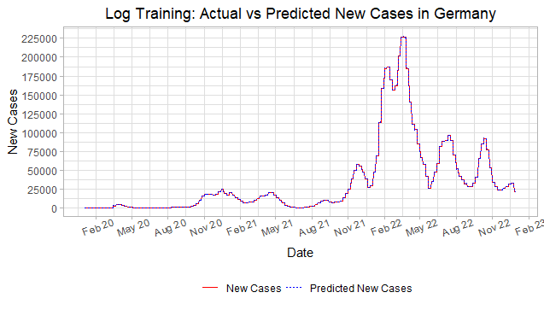

F. LSTM Model

**1. Data Preparation**

For the LSTM model, the neural network dataset is used since LSTM is a recurrent Neural Network. First, the data is filtered to only have observations after the first instance of COVID-19 for any country in the dataset which is January 4, 2020. Next, I selected 2 predictors, **new_deaths** and **new_tests**, which have high correlation with the response **new_cases**, as indicated by the high correlation coefficient in Table 2 and 4 in the Appendices. Additionally, geographic and country data predictors are added which includes **location**, **gdp_per_capita**, and **new_tests_b**, the missingness indicator for new_tests, for a total of 5 predictors. All the predictors are normalized and new_tests_b is converted into a dummy variable.

**2. Model Building**

The LSTM model was implemented using R’s **keras** package directly using an example[6]. First, a lagged predictor is created for the response new_cases, which I chose to be a lag of 7 for one week. Then, the lagged predictor and the 5 normalized predictors mentioned previously are merged into a 3d array. Next, a LSTM model was built with an initial layer of 5 **units**, in which the number of units will be a parameter tuned, along with fixed parameters **return_sequences** = TRUE and **stateful** = TRUE. A dropout layer is also added to lessen overfitting along with another LSTM layer with 5 units and finally, a dense layer to the output of the LSTM. Then, the LSTM model is compiled with a mean squared error loss function and using the Adaptive Moment Estimation, “adam”, optimizer with the mean absolute error metric. Finally, the LSTM model is trained with the predictors mentioned previously converted into a 3d array with the number of **epochs** being a parameter tuned.

|  |  |
| --- | --- |
| Fixed | Tune |
| * return_sequence = TRUE * stateful = TRUE | * units = {20, 30} * epochs = {10, 20} |

The main challenge was finding out how to implement the LSTM model as the format in constructing the model and preparing the data was vastly different from classical machine learning models. I had to search through several examples to get somewhat of a grasp on how to prepare the data such as transforming it into a 3d array and determining how to set up the LSTM inputs such that it can use the predictors converted into a 3d array. Another challenge was that I was unable to utilize all predictors for the LSTM model since I had to normalize and convert each predictor into the 3d array so utilizing all predictors became difficult to implement and time consuming. Thus, only the 5 predictors mentioned above along with the 7 lagged **new_cases** predictor were the only predictors used to build the LSTM model. The best parameters that minimizes the metric RMSE are:

**units** = 30 **epochs** = 10

Additionally, in order to improve performance by lowering the metric RMSE, I applied a log transformation to **new_cases** and then, applied the LSTM model tuning with the best parameters that minimizes the metric RMSE are:

**units** = 20 **epochs** = 10

**3. Model Performance**

The RMSE for the LSTM and log LSTM models on the training and testing sets:

|  |  |  |  |  |  |  |
| --- | --- | --- | --- | --- | --- | --- |
| Country | Argentina | Australia | Canada | Colombia | Ecuador | Ethiopia |
| Train RMSE | 19497 | 22004 | 20217 | 18153 | 21913 | 22702 |
| Test RMSE | 21185 | 19880 | 21164 | 21663 | 21788 | 21964 |
| log Train RMSE | 9531 | 20014 | 19519 | 3895 | 1954 | 580 |
| log Test RMSE | 5359 | 21503 | 5223 | 231 | 144 | 37 |
| Country | France | Germany | India | Italy | Japan | Mexico |
| Train RMSE | 23915 | 18664 | 32535 | 22195 | 28535 | 16868 |
| Test RMSE | 19454 | 20202 | 21119 | 19960 | 28268 | 18992 |
| log Train RMSE | 47011 | 43566 | 57977 | 20620 | 35268 | 5653 |
| log Test RMSE | 15998 | 21472 | 1215 | 8663 | 29071 | 1511 |
| Country | Morocco | Pakistan | Philippines | Russia | Saudi Arabia | South Africa |
| Train RMSE | 19456 | 19358 | 18087 | 16524 | 20327 | 18314 |
| Test RMSE | 20654 | 20707 | 20316 | 16515 | 20911 | 20946 |
| log Train RMSE | 1544 | 1251 | 3525 | 18495 | 5959 | 3428 |
| log Test RMSE | 48 | 53 | 619 | 3689 | 1071 | 363 |
| Country | South Korea | Sri Lanka | Turkey | United Kingdom | United States |  |
| Train RMSE | 31106 | 20344 | 15580 | 20914 | 72201 |  |
| Test RMSE | 25929 | 20588 | 20667 | 18839 | 21919 |  |
| log Train RMSE | 45348 | 1782 | 10598 | 17104 | 115006 |  |
| log Test RMSE | 25452 | 29 | 11 | 3970 | 13476 |  |

In general, the non-transformed LSTM model is one of the worst performing models alongside the non-transformed ARIMA and AutoARIMA models as indicated by the large train and test RMSE. However, the log transformation LSTM model is one of the best performing models as indicated by the low test RMSE. The R code for the LSTM model is in Github Repository in **Models/regular/wx_lstm.R** and **Models/log/wx_lstm_log.R**.

Plots of a Stationary Country - United States

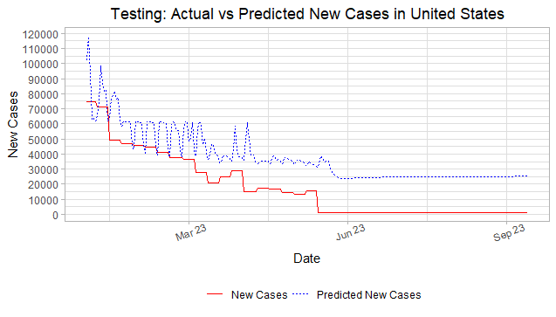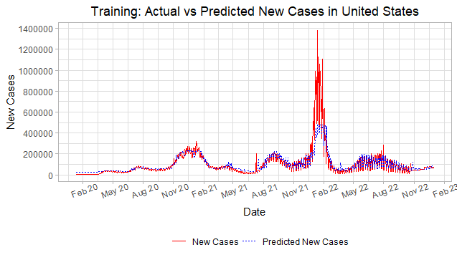

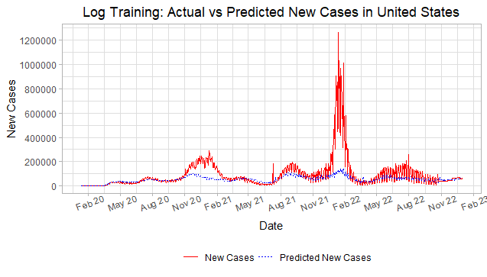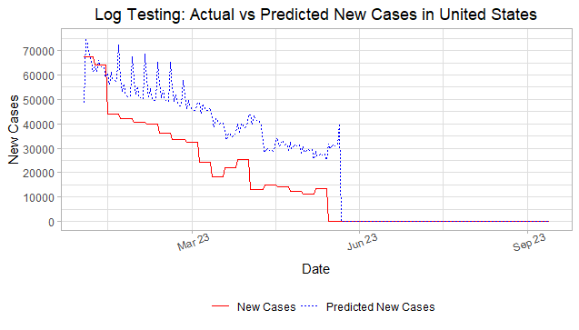

Plots of a Non-Stationary Country - Germany

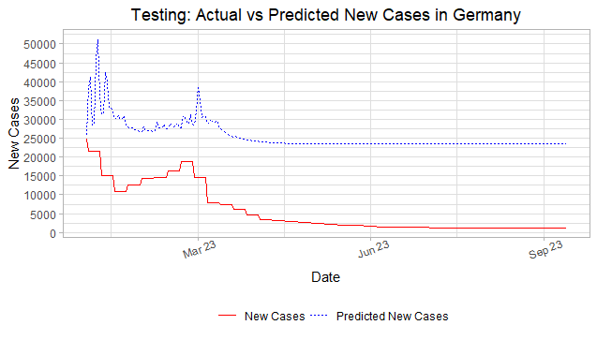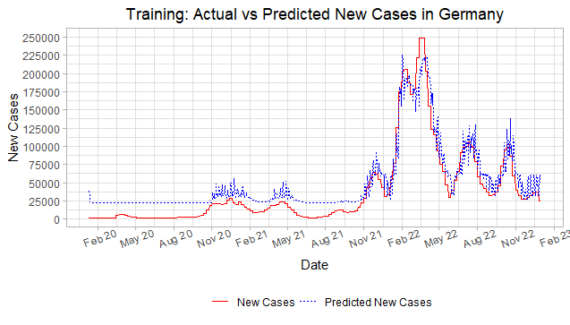

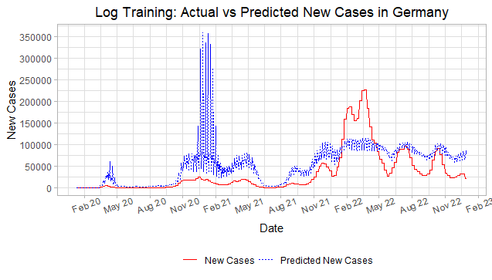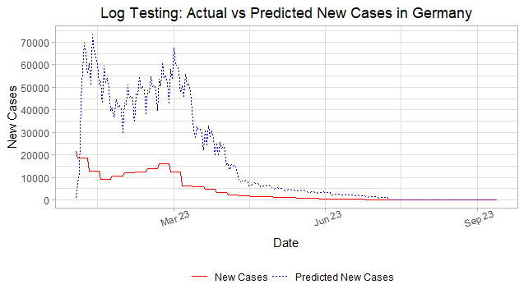

**IV. Results**

A. Model Performance Comparison

A table of each country’s test RMSE for each model and their log transformed version:

|  |  |  |  |  |  |  |
| --- | --- | --- | --- | --- | --- | --- |
| Country | Argentina | Australia | Canada | Colombia | Ecuador | Ethiopia |
| ARIMA | 16177 | 37152 | 7372 | 6219 | 1772 | 332 |
| AutoARIMA | 19440 | 17139 | 8648 | 5958 | 1880 | 402 |
| Prophet (Uni) | 4274 | 5091 | 8190 | 6422 | 10649 | 11066 |
| Prophet (Multi) | 3250 | 7145 | 3535 | 2813 | 3023 | 2381 |
| XGBoost | 5354 | 12856 | 6389 | 4100 | 2416 | 2056 |
| LSTM | 21185 | 19880 | 21164 | 21663 | 21788 | 21964 |
| log ARIMA | 43006 | 52424 | 546 | 4967 | 4967 | 113 |
| log AutoARIMA | 8579 | 140080 | 643 | 1174 | 1495 | 37 |
| log Prophet (Uni) | 1408 | 3178 | 446 | 658 | 111 | 51 |
| log Prophet (Multi) | 722 | 2220 | 373 | 84 | 48 | 12 |
| log XGBoost | 292 | 1611 | 279 | 44 | 47 | 2 |
| log LSTM | 5359 | 21503 | 5223 | 231 | 144 | 37 |
| Country | France | Germany | India | Italy | Japan | Mexico |
| ARIMA | 96537 | 95225 | 53727 | 32833 | 123645 | 8437 |
| AutoARIMA | 105095 | 112814 | 57545 | 72417 | 96071 | 12385 |
| Prophet (Uni) | 20680 | 19346 | 29049 | 9394 | 36683 | 6405 |
| Prophet (Multi) | 9746 | 8326 | 3127 | 4364 | 15119 | 2719 |
| XGBoost | 18441 | 22620 | 10799 | 14501 | 64125 | 9010 |
| LSTM | 19454 | 20202 | 21119 | 19960 | 28268 | 18992 |
| log ARIMA | 11917 | 52656 | 2736 | 2823 | 134905 | 4694 |
| log AutoARIMA | 68979 | 646442 | 2838 | 8369 | 257184 | 22386 |
| log Prophet (Uni) | 2753 | 4712 | 3839 | 2618 | 40091 | 841 |
| log Prophet (Multi) | 6136 | 7455 | 683 | 2900 | 4719 | 465 |
| log XGBoost | 1358 | 2486 | 834 | 1407 | 20480 | 518 |
| log LSTM | 15998 | 21472 | 1215 | 8663 | 29071 | 1511 |
| Country | Morocco | Pakistan | Philippines | Russia | Saudi Arabia | South Africa |
| ARIMA | 1442 | 1012 | 4436 | 22070 | 1478 | 3380 |
| AutoARIMA | 1340 | 1155 | 5195 | 44662 | 793 | 3629 |
| Prophet (Uni) | 10416 | 10155 | 8510 | 5311 | 10821 | 8136 |
| Prophet (Multi) | 2959 | 3163 | 3106 | 2535 | 2992 | 2283 |
| XGBoost | 2319 | 2098 | 4579 | 13588 | 2039 | 2131 |
| LSTM | 20654 | 20707 | 20316 | 16515 | 20911 | 20946 |
| log ARIMA | 23 | 33 | 341 | 3160 | 99 | 132 |
| log AutoARIMA | 145 | 36 | 421 | 21085 | 139 | 145 |
| log Prophet (Uni) | 124 | 192 | 400 | 3890 | 114 | 371 |
| log Prophet (Multi) | 8 | 22 | 361 | 1391 | 32 | 97 |
| log XGBoost | 7 | 3 | 198 | 1970 | 17 | 52 |
| log LSTM | 48 | 53 | 619 | 3689 | 1071 | 363 |
| Country | South Korea | Sri Lanka | Turkey | United Kingdom | United States |  |
| ARIMA | 101029 | 487 | 34135 | 47814 | 126535 |  |
| AutoARIMA | 101376 | 536 | 35506 | 43918 | 174562 |  |
| Prophet (Uni) | 17097 | 10913 | 6178 | 9756 | 66128 |  |
| Prophet (Multi) | 13515 | 2906 | 5533 | 3490 | 14778 |  |
| XGBoost | 56720 | 1555 | 1243 | 6367 | 58104 |  |
| LSTM | 25929 | 20588 | 20667 | 18839 | 21919 |  |
| log ARIMA | 1022714 | 4 | 1 | 1629 | 16005 |  |
| log AutoARIMA | 987080 | 4 | 397 | 1929 | 16713 |  |
| log Prophet (Uni) | 21974 | 49 | 1861 | 1645 | 14828 |  |
| log Prophet (Multi) | 21803 | 5 | 4 | 1676 | 10949 |  |
| log XGBoost | 18173 | 1 | 1 | 612 | 10273 |  |
| log LSTM | 25452 | 29 | 11 | 3970 | 13476 |  |

In general, the best performing model in predicting new cases of COVID-19 by country level is the log transformed XGBoost model as indicated by the majority of the best test RMSE in red highlight in the log XGBoost row. Additionally, for a few countries, the log transformed Prophet (Multivariate) model performs as well as or even sometimes outperforms the log transformed XGBoost Model as indicated by the highlighted oranges test RMSE.

B. Analysis of Results

|  |  |  |
| --- | --- | --- |
| Model | Strengths | Weaknesses |
| ARIMA | * Easy to implement * Able to easily use past data to predict new data | * Does not handle non-linear data well * Does not handle outliers well * Only one predictor = Date → Results not very accurate * Manually rerun model to apply to each country * Model tuning and training is somewhat slow |
| AutoARIMA | * Easy to implement * Able to easily use past data to predict new data * Model tuning and training is quick | * Does not handle non-linear data well * Does not handle outliers well * Only one predictor = Date → Results not very accurate * Manually rerun model to apply to each country |
| Prophet (Univariate) | * Apply model to every country at once | * One one predictor = Date → Results not very accurate * Model tuning and training is slow |
| Prophet (Multivariate) | * Easy to implement * Apply model to every country at once * Apply time series data easier with multivariate regressors | * Can tend to overfit the training data → Results are not as accurate on the testing data * Model tuning and training is very slow |
| XGBoost | * Apply model to every country at once * Can accurately predict the general trend and outliers such as peaks * Handle missingness well using large imputations | * Can tend to overfit the training data → Results are not as accurate on the testing data * Model tuning and training is very slow |
| LSTM | * Apply model to every country at once * Can accurately predict the general trend * Handle missingness well using indicator predictors | * Hard to implement due to different format for inputs and different way to train model * Can sometimes handle outliers / peaks * Model tuning and training is slow |

I believe that the XGBoost model performed the best because (1) it was able to use all the predictors available compared to some models like ARIMA and Prophet (Univariate), (2) it was able to handle missingness in the data very well since such missingness is imputed with a large value (i.e. 1015), and (3) most models can predict the general trend, but not outliers like large peaks, but XGBoost are able to predict both the trend and large peaks.

**V. Discussion**

* The LSTM model is not as accurate in predicting COVID-19 cases as the other models since it isn’t a classical machine learning model and is implemented with more complexity. Due to my lack of experience and knowledge on how neural networks work especially for recurrent neural networks, I am unable to determine even the issues that my LSTM model might be having. I can only visualize why the model is not performing well, but have no understanding on why the LSTM is performing the way it is.
* During my time in this class and working on this project, I think I gain some valuable experience in learning new types of machine learning models like Prophet and LSTM, but I think the amount of confusion and time spent on learning how to implement and constantly fixing the model such that it can work property was too time consuming.
* I liked how the project is structured using version control and weekly reports since it provides a clear way to communicate to group members while staying organized and the weekly reports gave me a concrete way to set personal deadlines and address issues in order to maintain progress on the project. I disliked how messy the dataset was such that I kept finding more and more issues with the dataset that isn’t as obvious as missingness or collinearity which meant everytime I fixed the dataset, I had to rerun all my models again which was very frustrating and time consuming.

**VI. Conclusion**

* The best model to predict new cases of COVID-19 by country level is a log transformed XGBoost model followed by a log transformed Prophet (Multivariate) model.
* The worst models to predict new cases of COVID-19 by country level are the non-transformed ARIMA and AutoARIMA models.
* In general, log transformation on new cases of COVID-19 helps to improve a model’s accuracy in predicting new cases of COVID-19.
* Consistent communication is an essential key part in a collaborative learning environment in order to address issues and provide solutions, maintain deadlines, and clear up misunderstandings about machine learning models and processes.
* It is also important to be organized and clear when making contributions to a group project such that member’s tasks are clearly understood and beneficial in furthering the progress of the project rather than being stuck, disorganized, and fixing errors.

**VII. References**

1. Dataset Source: Our World in Data. (2023). Our World in Data - COVID-19 [Data set]. Kaggle. <https://doi.org/10.34740/KAGGLE/DSV/6559049>
2. “K-Means Cluster Analysis.” K-Means Cluster Analysis · UC Business Analytics R Programming Guide, University of Cincinnati, uc-r.github.io/kmeans_clustering. Accessed 26 Nov. 2023.
3. Science, Business. “Introducing Modeltime: Tidy Time Series Forecasting Using Tidymodels: R-Bloggers.” R-Bloggers, 29 June 2020, [www.r-bloggers.com/2020/06/introducing-modeltime-tidy-time-series-forecasting-using-tidymodels/](http://www.r-bloggers.com/2020/06/introducing-modeltime-tidy-time-series-forecasting-using-tidymodels/).
4. Silge, Julia. “Tune XGBoost with Tidymodels and #tidytuesday Beach Volleyball.” Julia Silge Blog, 21 May 2020, juliasilge.com/blog/xgboost-tune-volleyball/.
5. “LSTM TIME SERIES PREDICTION IN R.” Data Side of Life, 5 Jan. 2020, datasideoflife.com/?p=1171.

**VIII. Appendices**

* Source 1: Data Science Project Github Repository

<https://github.com/AzureAmber/STAT-390-Covid-Project/tree/main>

* Table 1: Data Missingness

|  |  |  |  |
| --- | --- | --- | --- |
| **skim_type** | **skim_variable** | **n_missing** | **complete_rate** |
| numeric | excess_mortality_cumulative_absolute | 28693 | 7.64% |
| numeric | excess_mortality_cumulative | 28693 | 7.64% |
| numeric | excess_mortality | 28693 | 7.64% |
| numeric | excess_mortality_cumulative_per_million | 28693 | 7.64% |
| numeric | weekly_icu_admissions | 28193 | 9.25% |
| numeric | weekly_icu_admissions_per_million | 28193 | 9.25% |
| numeric | weekly_hosp_admissions | 24846 | 20.02% |
| numeric | weekly_hosp_admissions_per_million | 24846 | 20.02% |
| numeric | hosp_patients | 22647 | 27.10% |
| numeric | hosp_patients_per_million | 22647 | 27.10% |
| numeric | total_boosters | 21913 | 29.46% |
| numeric | total_boosters_per_hundred | 21913 | 29.46% |
| numeric | handwashing_facilities | 20258 | 34.79% |
| numeric | icu_patients | 20250 | 34.82% |
| numeric | icu_patients_per_million | 20250 | 34.82% |
| numeric | new_vaccinations | 18229 | 41.32% |
| numeric | people_fully_vaccinated | 17978 | 42.13% |
| numeric | people_fully_vaccinated_per_hundred | 17978 | 42.13% |
| numeric | people_vaccinated | 17661 | 43.15% |
| numeric | people_vaccinated_per_hundred | 17661 | 43.15% |
| numeric | total_vaccinations | 17191 | 44.66% |
| numeric | total_vaccinations_per_hundred | 17191 | 44.66% |
| numeric | new_tests | 14004 | 54.92% |
| numeric | new_tests_per_thousand | 14004 | 54.92% |
| numeric | total_tests | 13518 | 56.49% |
| numeric | total_tests_per_thousand | 13518 | 56.49% |
| numeric | tests_per_case | 13137 | 57.71% |
| numeric | positive_rate | 13061 | 57.96% |
| numeric | new_people_vaccinated_smoothed | 12484 | 59.81% |
| numeric | new_people_vaccinated_smoothed_per_hundred | 12484 | 59.81% |
| numeric | new_vaccinations_smoothed | 12408 | 60.06% |
| numeric | new_vaccinations_smoothed_per_million | 12408 | 60.06% |
| numeric | new_tests_smoothed | 12064 | 61.17% |
| numeric | new_tests_smoothed_per_thousand | 12064 | 61.17% |
| character | tests_units | 11903 | 61.68% |
| numeric | reproduction_rate | 7474 | 75.94% |
| numeric | extreme_poverty | 6750 | 78.27% |
| numeric | stringency_index | 5900 | 81.01% |
| numeric | total_deaths | 1495 | 95.19% |
| numeric | total_deaths_per_million | 1495 | 95.19% |
| numeric | total_cases | 911 | 97.07% |
| numeric | total_cases_per_million | 911 | 97.07% |
| numeric | new_cases_smoothed | 284 | 99.09% |
| numeric | new_cases_smoothed_per_million | 284 | 99.09% |
| numeric | new_deaths_smoothed | 259 | 99.17% |
| numeric | new_deaths_smoothed_per_million | 259 | 99.17% |
| numeric | new_cases | 161 | 99.48% |
| numeric | new_cases_per_million | 161 | 99.48% |
| numeric | new_deaths | 144 | 99.54% |
| numeric | new_deaths_per_million | 144 | 99.54% |
| Date | date | 0 | 100.00% |
| character | iso_code | 0 | 100.00% |
| character | continent | 0 | 100.00% |
| character | location | 0 | 100.00% |
| character | day_of_week | 0 | 100.00% |
| factor | month | 0 | 100.00% |
| logical | G20 | 0 | 100.00% |
| logical | G24 | 0 | 100.00% |
| numeric | population_density | 0 | 100.00% |
| numeric | median_age | 0 | 100.00% |
| numeric | aged_65_older | 0 | 100.00% |
| numeric | aged_70_older | 0 | 100.00% |
| numeric | gdp_per_capita | 0 | 100.00% |
| numeric | cardiovasc_death_rate | 0 | 100.00% |
| numeric | diabetes_prevalence | 0 | 100.00% |
| numeric | female_smokers | 0 | 100.00% |
| numeric | male_smokers | 0 | 100.00% |
| numeric | hospital_beds_per_thousand | 0 | 100.00% |
| numeric | life_expectancy | 0 | 100.00% |
| numeric | human_development_index | 0 | 100.00% |
| numeric | population | 0 | 100.00% |

* Table 2: Correlation between new_cases and variables with large missingness

|  |  |
| --- | --- |
|  | new_cases |
| hosp_patients | 0.51 |
| weekly_hosp_admissions | 0.45 |
| new_tests | 0.39 |
| icu_patients | 0.38 |
| people_vaccinated | 0.38 |
| people_fully_vaccinated | 0.37 |
| total_vaccinations | 0.36 |
| new_vaccinations_smoothed | 0.33 |
| total_tests | 0.32 |
| total_boosters | 0.30 |
| new_vaccinations | 0.29 |
| new_people_vaccinated_smoothed | 0.24 |
| weekly_hosp_admissions_per_million | 0.22 |
| weekly_icu_admissions | 0.19 |
| positive_rate | 0.14 |
| excess_mortality_cumulative_absolute | 0.13 |
| hosp_patients_per_million | 0.12 |
| icu_patients_per_million | 0.11 |
| weekly_icu_admissions_per_million | 0.08 |
| new_tests_smoothed | 0.06 |
| new_tests_smoothed_per_thousand | 0.06 |
| total_vaccinations_per_hundred | 0.06 |
| total_tests_per_thousand | 0.05 |
| people_vaccinated_per_hundred | 0.05 |
| people_fully_vaccinated_per_hundred | 0.05 |
| new_tests_per_thousand | 0.04 |
| handwashing_facilities | 0.02 |
| new_vaccinations_smoothed_per_million | 0.01 |
| excess_mortality | 0.01 |
| excess_mortality_cumulative_per_million | 0.00 |
| new_people_vaccinated_smoothed_per_hundred | -0.01 |
| tests_per_case | -0.01 |
| excess_mortality_cumulative | -0.01 |
| total_boosters_per_hundred | -0.03 |

* Table 3: Correlation Matrix for Multicollinearity

|  |  |  |  |  |  |  |  |  |  |  |  |  |  |  |  |  |  |
| --- | --- | --- | --- | --- | --- | --- | --- | --- | --- | --- | --- | --- | --- | --- | --- | --- | --- |
|  | total_cases | new_cases | new_cases_smoothed | total_deaths | new_deaths | new_deaths_smoothed | new_cases_smoothed_per_million | median_age | aged_65_older | aged_70_older | gdp_per_capita | extreme_poverty | female_smokers | male_smokers | life_expectancy | human_development_index | population |
| total_cases | 1.00 | 0.37 | 0.44 | 0.94 | 0.30 | 0.33 | 0.00 | 0.05 | 0.04 | 0.04 | 0.02 | -0.04 | 0.00 | 0.00 | 0.02 | 0.05 | 0.65 |
| new_cases | 0.37 | 1.00 | 0.84 | 0.43 | 0.50 | 0.43 | 0.07 | 0.03 | 0.03 | 0.03 | 0.01 | -0.03 | 0.00 | 0.01 | 0.02 | 0.03 | 0.37 |
| new_cases_smoothed | 0.44 | 0.84 | 1.00 | 0.50 | 0.48 | 0.51 | 0.08 | 0.04 | 0.03 | 0.03 | 0.02 | -0.03 | 0.00 | 0.01 | 0.02 | 0.03 | 0.44 |
| total_deaths | 0.94 | 0.43 | 0.50 | 1.00 | 0.47 | 0.52 | 0.00 | 0.04 | 0.03 | 0.03 | 0.01 | -0.05 | -0.01 | 0.00 | 0.01 | 0.04 | 0.74 |
| new_deaths | 0.30 | 0.50 | 0.48 | 0.47 | 1.00 | 0.91 | 0.02 | 0.03 | 0.03 | 0.03 | 0.01 | -0.04 | -0.01 | 0.00 | 0.01 | 0.04 | 0.58 |
| new_deaths_smoothed | 0.33 | 0.43 | 0.51 | 0.52 | 0.91 | 1.00 | 0.02 | 0.04 | 0.03 | 0.03 | 0.01 | -0.04 | -0.01 | 0.00 | 0.01 | 0.04 | 0.64 |
| total_cases_per_million | 0.07 | 0.00 | 0.00 | 0.02 | -0.04 | -0.05 | 0.19 | 0.48 | 0.46 | 0.46 | 0.41 | -0.35 | 0.41 | 0.06 | 0.44 | 0.50 | -0.07 |
| new_cases_per_million | 0.00 | 0.09 | 0.04 | 0.00 | 0.03 | 0.01 | 0.52 | 0.14 | 0.14 | 0.13 | 0.11 | -0.09 | 0.10 | 0.01 | 0.09 | 0.14 | -0.01 |
| new_cases_smoothed_per_million | 0.00 | 0.07 | 0.08 | 0.00 | 0.02 | 0.02 | 1.00 | 0.25 | 0.25 | 0.25 | 0.19 | -0.16 | 0.18 | 0.02 | 0.17 | 0.24 | -0.02 |
| total_deaths_per_million | 0.10 | 0.02 | 0.03 | 0.11 | 0.01 | 0.01 | 0.11 | 0.49 | 0.48 | 0.48 | 0.19 | -0.39 | 0.45 | 0.12 | 0.38 | 0.44 | -0.06 |
| new_deaths_per_million | -0.01 | 0.04 | 0.02 | 0.00 | 0.11 | 0.06 | 0.14 | 0.15 | 0.15 | 0.15 | 0.06 | -0.12 | 0.13 | 0.03 | 0.09 | 0.13 | -0.01 |
| new_deaths_smoothed_per_million | -0.01 | 0.03 | 0.04 | 0.00 | 0.10 | 0.11 | 0.24 | 0.27 | 0.27 | 0.27 | 0.11 | -0.21 | 0.24 | 0.06 | 0.17 | 0.24 | -0.02 |
| reproduction_rate | 0.02 | 0.02 | 0.02 | 0.03 | 0.03 | 0.03 | 0.09 | 0.25 | 0.22 | 0.22 | 0.17 | -0.21 | 0.14 | 0.00 | 0.25 | 0.24 | 0.05 |
| stringency_index | -0.11 | 0.02 | 0.02 | -0.05 | 0.14 | 0.16 | -0.01 | 0.04 | -0.01 | -0.01 | 0.01 | -0.11 | -0.08 | 0.03 | 0.06 | 0.07 | 0.12 |
| population_density | -0.01 | -0.01 | -0.01 | -0.02 | -0.02 | -0.02 | 0.05 | 0.15 | 0.07 | 0.04 | 0.37 | -0.03 | -0.05 | 0.00 | 0.22 | 0.18 | -0.02 |
| median_age | 0.05 | 0.03 | 0.04 | 0.04 | 0.03 | 0.04 | 0.25 | 1.00 | 0.91 | 0.90 | 0.65 | -0.70 | 0.64 | 0.17 | 0.83 | 0.90 | 0.01 |
| aged_65_older | 0.04 | 0.03 | 0.03 | 0.03 | 0.03 | 0.03 | 0.25 | 0.91 | 1.00 | 0.99 | 0.50 | -0.57 | 0.73 | 0.08 | 0.73 | 0.78 | 0.00 |
| aged_70_older | 0.04 | 0.03 | 0.03 | 0.03 | 0.03 | 0.03 | 0.25 | 0.90 | 0.99 | 1.00 | 0.49 | -0.56 | 0.73 | 0.08 | 0.71 | 0.77 | -0.01 |
| gdp_per_capita | 0.02 | 0.01 | 0.02 | 0.01 | 0.01 | 0.01 | 0.19 | 0.65 | 0.50 | 0.49 | 1.00 | -0.50 | 0.31 | -0.10 | 0.68 | 0.75 | -0.03 |
| extreme_poverty | -0.04 | -0.03 | -0.03 | -0.05 | -0.04 | -0.04 | -0.16 | -0.70 | -0.57 | -0.56 | -0.50 | 1.00 | -0.41 | -0.19 | -0.75 | -0.78 | -0.03 |
| cardiovasc_death_rate | -0.04 | -0.03 | -0.03 | -0.04 | -0.04 | -0.04 | -0.13 | -0.34 | -0.34 | -0.36 | -0.48 | 0.19 | -0.14 | 0.43 | -0.47 | -0.42 | -0.02 |
| diabetes_prevalence | 0.00 | 0.00 | 0.00 | 0.01 | 0.00 | 0.00 | 0.04 | 0.14 | -0.05 | -0.08 | 0.12 | -0.38 | 0.09 | 0.20 | 0.20 | 0.20 | 0.00 |
| female_smokers | 0.00 | 0.00 | 0.00 | -0.01 | -0.01 | -0.01 | 0.18 | 0.64 | 0.73 | 0.73 | 0.31 | -0.41 | 1.00 | 0.23 | 0.44 | 0.55 | -0.06 |
| male_smokers | 0.00 | 0.01 | 0.01 | 0.00 | 0.00 | 0.00 | 0.02 | 0.17 | 0.08 | 0.08 | -0.10 | -0.19 | 0.23 | 1.00 | 0.05 | 0.09 | 0.01 |
| hospital_beds_per_thousand | 0.02 | 0.01 | 0.02 | 0.00 | 0.00 | 0.00 | 0.13 | 0.63 | 0.60 | 0.60 | 0.29 | -0.44 | 0.47 | 0.35 | 0.42 | 0.56 | -0.02 |
| life_expectancy | 0.02 | 0.02 | 0.02 | 0.01 | 0.01 | 0.01 | 0.17 | 0.83 | 0.73 | 0.71 | 0.68 | -0.75 | 0.44 | 0.05 | 1.00 | 0.91 | -0.02 |
| human_development_index | 0.05 | 0.03 | 0.03 | 0.04 | 0.04 | 0.04 | 0.24 | 0.90 | 0.78 | 0.77 | 0.75 | -0.78 | 0.55 | 0.09 | 0.91 | 1.00 | 0.00 |
| population | 0.65 | 0.37 | 0.44 | 0.74 | 0.58 | 0.64 | -0.02 | 0.01 | 0.00 | -0.01 | -0.03 | -0.03 | -0.06 | 0.01 | -0.02 | 0.00 | 1.00 |

* Table 4: Initial Stationary Check for ARIMA by ADF Values

|  |  |  |  |
| --- | --- | --- | --- |
| Country | ADF | P-value | Result |
| Argentina | -4.21 | 0.01 | Stationary |
| Australia | -2.02 | 0.57 | Non-Stationary |
| Canada | -3.25 | 0.08 | Non-Stationary |
| Colombia | -3.47 | 0.05 | Stationary |
| Ecuador | -4.68 | 0.01 | Stationary |
| Ethiopia | -4.19 | 0.01 | Stationary |
| France | -2.45 | 0.39 | Non-Stationary |
| Germany | -2.52 | 0.36 | Non-Stationary |
| India | -3.78 | 0.02 | Stationary |
| Italy | -2.73 | 0.27 | Non-Stationary |
| Japan | -4.32 | 0.01 | Stationary |
| Mexico | -4.47 | 0.01 | Stationary |
| Morocco | -4.13 | 0.01 | Stationary |
| Pakistan | -4.25 | 0.01 | Stationary |
| Philippines | -3.59 | 0.04 | Stationary |
| Russia | -3.40 | 0.06 | Non-Stationary |
| Saudi Arabia | -3.85 | 0.02 | Stationary |
| South Africa | -4.07 | 0.01 | Stationary |
| South Korea | -3.46 | 0.05 | Stationary |
| Sri Lanka | -2.83 | 0.23 | Non-Stationary |
| Turkey | -3.56 | 0.04 | Stationary |
| United Kingdom | -2.92 | 0.19 | Non-Stationary |
| United States | -3.92 | 0.01 | Stationary |

* Table 5: Stationary Check with Manual ARIMA

|  |  |  |  |
| --- | --- | --- | --- |
| Country | ADF | P-value | Result |
| Argentina | -3.34 | 0.07 | Non-Stationary |
| Australia | -2.01 | 0.57 | Non-Stationary |
| Canada | -3.13 | 0.11 | Non-Stationary |
| Colombia | -2.52 | 0.36 | Non-Stationary |
| Ecuador | -4.24 | 0.01 | Stationary |
| Ethiopia | -3.21 | 0.09 | Non-Stationary |
| France | -2.57 | 0.34 | Non-Stationary |
| Germany | -2.82 | 0.23 | Non-Stationary |
| India | -3.29 | 0.08 | Non-Stationary |
| Italy | -3.32 | 0.07 | Non-Stationary |
| Japan | -3.51 | 0.04 | Stationary |
| Mexico | -4.41 | 0.01 | Stationary |
| Morocco | -4.11 | 0.01 | Stationary |
| Pakistan | -3.94 | 0.01 | Stationary |
| Philippines | -3.07 | 0.13 | Non-Stationary |
| Russia | -3.58 | 0.04 | Stationary |
| Saudi Arabia | -3.22 | 0.09 | Non-Stationary |
| South Africa | -2.92 | 0.19 | Non-Stationary |
| South Korea | -3.80 | 0.02 | Stationary |
| Sri Lanka | -1.67 | 0.71 | Non-Stationary |
| Turkey | -3.75 | 0.02 | Stationary |
| United Kingdom | -0.86 | 0.95 | Non-Stationary |
| United States | -3.72 | 0.02 | Stationary |

* Table 6: Stationary Check for Manual log ARIMA

|  |  |  |  |
| --- | --- | --- | --- |
| Country | ADF | P-value | Result |
| Argentina | -4.51 | 0.01 | Stationary |
| Australia | -1.67 | 0.72 | Non-Stationary |
| Canada | -5.09 | 0.01 | Stationary |
| Colombia | -4.29 | 0.01 | Stationary |
| Ecuador | -4.69 | 0.01 | Stationary |
| Ethiopia | -3.11 | 0.11 | Non-Stationary |
| France | -2.40 | 0.41 | Non-Stationary |
| Germany | -6.07 | 0.01 | Stationary |
| India | -4.57 | 0.01 | Stationary |
| Italy | -6.63 | 0.01 | Stationary |
| Japan | -4.47 | 0.01 | Stationary |
| Mexico | -5.99 | 0.01 | Stationary |
| Morocco | -3.90 | 0.02 | Stationary |
| Pakistan | -3.52 | 0.04 | Stationary |
| Philippines | -3.79 | 0.02 | Stationary |
| Russia | -5.19 | 0.01 | Stationary |
| Saudi Arabia | -4.95 | 0.01 | Stationary |
| South Africa | -3.54 | 0.04 | Stationary |
| South Korea | -5.98 | 0.01 | Stationary |
| Sri Lanka | -2.08 | 0.54 | Non-Stationary |
| Turkey | -2.37 | 0.42 | Non-Stationary |
| United Kingdom | -4.59 | 0.01 | Stationary |
| United States | -8.69 | 0.01 | Stationary |

1. Dataset Source: Our World in Data. (2023). Our World in Data - COVID-19 [Data set]. Kaggle. <https://doi.org/10.34740/KAGGLE/DSV/6559049>
2. “K-Means Cluster Analysis.” K-Means Cluster Analysis · UC Business Analytics R Programming Guide, University of Cincinnati, uc-r.github.io/kmeans_clustering. Accessed 26 Nov. 2023.
3. <https://github.com/AzureAmber/STAT-390-Covid-Project/tree/main>
4. Science, Business. “Introducing Modeltime: Tidy Time Series Forecasting Using Tidymodels: R-Bloggers.” R-Bloggers, 29 June 2020, [www.r-bloggers.com/2020/06/introducing-modeltime-tidy-time-series-forecasting-using-tidymodels/](http://www.r-bloggers.com/2020/06/introducing-modeltime-tidy-time-series-forecasting-using-tidymodels/).
5. Silge, Julia. “Tune XGBoost with Tidymodels and #tidytuesday Beach Volleyball.” Julia Silge Blog, 21 May 2020, juliasilge.com/blog/xgboost-tune-volleyball/.
6. “LSTM TIME SERIES PREDICTION IN R.” Data Side of Life, 5 Jan. 2020, datasideoflife.com/?p=1171.